March 14-25: Spring Break
March 28-31: Monday to Thursday
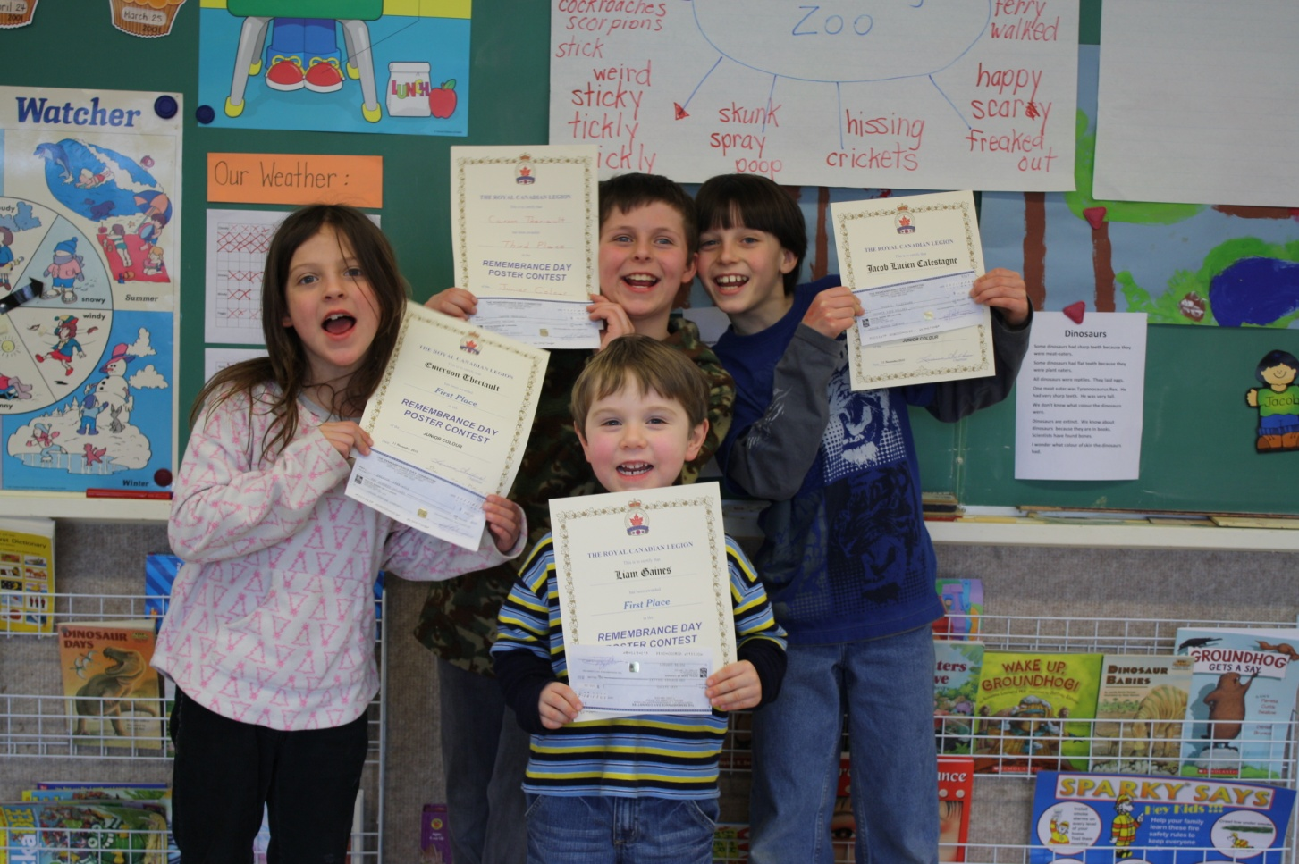
Winners !!!

Parent-Teacher Conferences
Tuesday March 29th

Early dismissal at 2:00 pm followed by Parent Conferences to be held from 2:00 pm to 3:00 pm. There will be student led conferences/parent-teacher time.
Poppy Poster Contest

The Royal Canadian Legion is proud to present First Prize to Liam Sohier Gaines and Emerson Theriault. Second prize went to Jacob Calestagne and Third Prize to Carson Theriault.

First Prize was a cheque for $100.00
Second Prize $75.00 and Third Prize was $50.00. We are so proud of all our winners. Congratulations!
Have a great
Spring Break
Everyone!!

